Tilt Table Setup Steps S24

1. Start with the code: “Tilt_Table_Basic_A”, Load it into MCUXpresso using the import command.
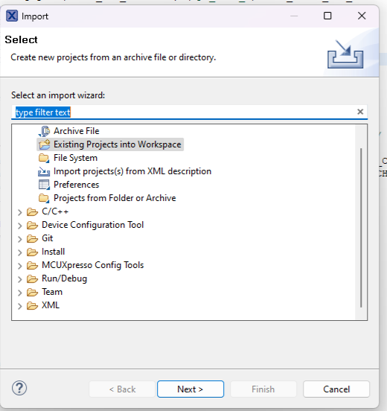
Note, you should use the second choice, “Existing Projects into Workspace” not the archive file selection (Even though it is an archive file! Very confusing.)
Then select the zip file also under the Lab 6 tab, “Tilt_Start_Basic_A.zip” and it should load in your MCUXpresso Workspace and be ready to go.

2. Now charge up a battery and get tilt table, a scope probe and scope. First we will check the servos for normal functioning.
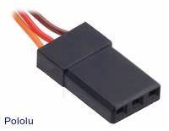
3. With the battery disconnected, connect the scope to one of the servo plugs. Use the ground clip on the ground pin and the scope probe on the signal pin. Nothing connected to the power pin, which should have 0.0V with the battery disconnected to reduce the chance of a short circuit. Verify the the PWM puse goes to ~1.0 ms and slowly increases to ~2.0 ms and then goes to 1.5 ms and stops.
Gnd
PWM
6.5V
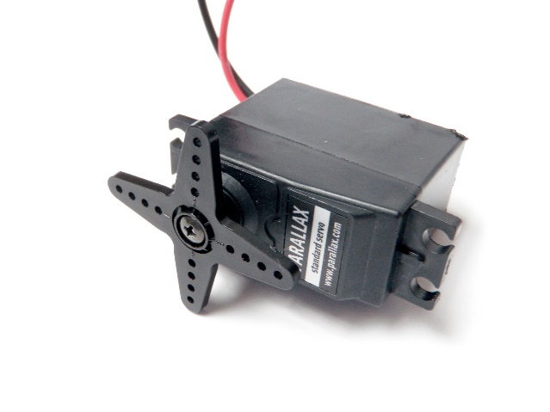4. Now connect the servos, making sure to plug them in the right way using the figure to the right. The 6.5 Volts is always the center pin, but you can mixup the PWM signal and Gnd pins. Now plug in the battery and run option 9 again. You should see fairly smooth movement from full down position to full up position in both servos. It may be that one or both servos work in the opposite direction. This happens because the servos are mounted various ways, but in all cases, the motion on the servo hub should be CCW (counter clockwise) as you look at the servo hub as in the photo. Note if your X and or Y servos work in the normal (Down to Up) mode or the opposite. Set the servoX_ direction and your servoY_direction to 0 for normal and 1 for opposite near the top of the program code.
CCW

5. Then run option 6. Option 6 should now move correctly with the 00 point for both X&Y in the down position and then both going up and then to level. Your level position may not be exactly level but if everything else works OK then you have correctly set your servoX_direction and your servoY_ direction. You are now ready to go to the leveling step.
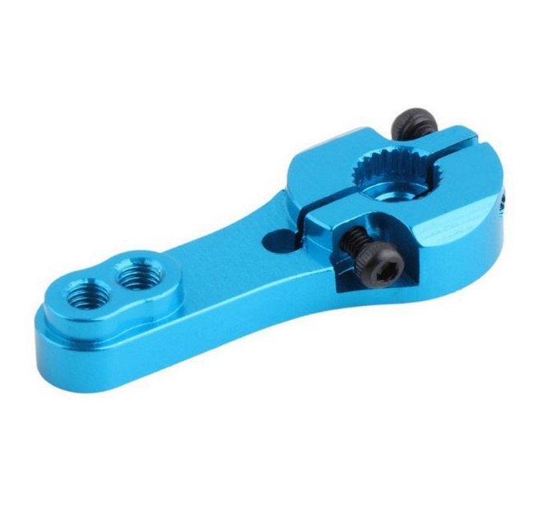
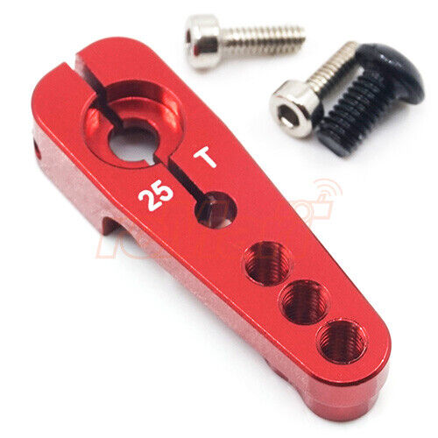
6. In the leveling step you should look and see how far out of level your servo is at the end of running option 6. If it's way out then it means that you're servo horn was not mounted level when the servo was in the neutral position (1.5 ms PWM pulse). If it's only a little bit out of level that's not a problem we'll just change the software but if it's way out of level (more than 150 +/- 20 or more) that is a problem and we have to change the servo horn. First make sure the Servo is left in the Nutral position, which it will be after running option 6. The servo horns are mounted with a center screw and then two small screws that go in opposite directions around the hub to tighten it down It will take a small Allen wrench to loosen the up and down hub screws and the center screw takes a little Phillips screwdriver loosen all these screws up with the servo set to the level position using option 5, pull off the servo arm and reposition it so it is as close to level as the teeth on the servo hub will allow. Because of the teeth it may not be able to be perfectly level and that's fine as long as it's close it will work fine and we'll make the final adjustments in software.

7. Now that we know that your servo horn is roughly parallel when the servos in the neutral position we will make small adjustments in the constant setting servoX_level and servoY_ level settings continuing running option 5 until we have the table as close to perfectly level as you can get it. To do this you have to run the battery and run the servos and disconnect the oscilloscope. There will be some small spirit levels available in the lab that you can use to help get your table level. Note your starting position should be 150 for level and then you can adjust it up or down a little bit again if you have to adjust it a lot then you probably need to loosen your servo arm and reposition it on the servo hub when the servo hub is set to the neutral position as described in step 6 above. To get it exactly level make very small adjustments in the level X setting and the level Y setting and keep running recompiling and running option 5 until you're satisfied that both your X&Y directions are very close to exactly level.
8. Now run option 6 again to see if the range of movement from full down to full up is adequate or whether it's excessive if it's uh if it's adequate and looks about right then you're done if it's excessive or inadequate, then you need to adjust the min X Max X min Y and Max Y settings so that the range of motion is reasonable and reasonable is probably plus or minus 30, 35 maybe 40° from level. Remember that if you have to exceed 200 going up and 100 going down then you should check with TA or Dr. Morton first because you'll have to change some other constants in the code in order to do that, because these are hard limits. At this point if everything looks good you're ready to build in the PID controller and then once you get that done you're ready to begin tuning it.

